|  |  |
| --- | --- |
| IAM Security Tools AWS Certified Security Specialty SCS-C02 | AWS Cloud Resource | IAM Policy |

In this section, we will cover the security tools available in IAM (Identity and Access Management) in AWS. These tools help us manage the security of our accounts and users effectively.

# Credential Report

We can generate an IAM Credential Report, which is at the account level. This report will include all users in your account and the status of their credentials.

To create this report, go to "Credential Report" in the sidebar and download the report, which will generate a CSV file.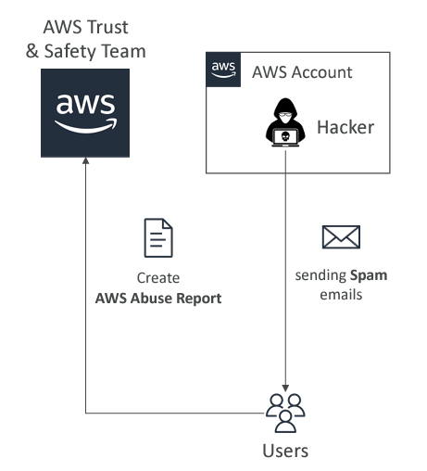

The report provides important information such as:

- When the user was created

- Whether the password is active

- When the password was last used and changed

- When the next password rotation is expected  
 “if password rotation is enabled”

- Multi-Factor Authentication (MFA) is enabled

- Access keys have been created or not

This report is extremely useful if we want to review users who have not changed their passwords or have not used their accounts.   
It can be a great tool to identify which users need our attention from a security perspective.

# Access Advisor:

It will show us the services accessed by the user and when they were accessed.

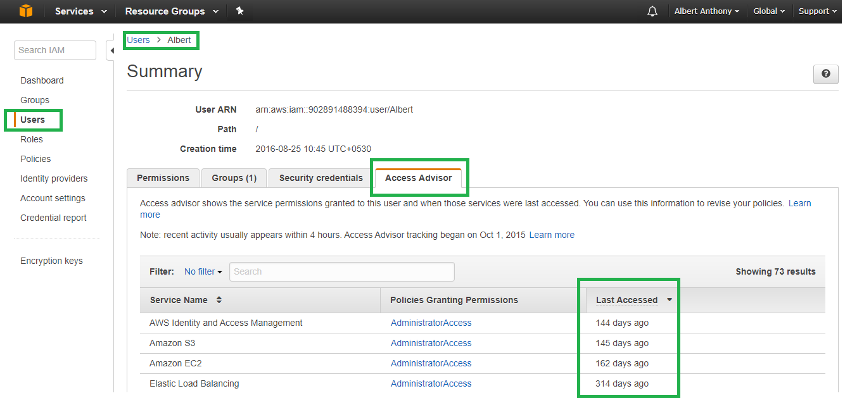

Using the Access Advisor, you can assess whether the user has the appropriate permissions. Based on this access data, it may become clear that the user only needs access to specific services rather than all of them. This interface provides the ability to drill down further to precisely define permissions.

The Access Advisor is very useful for managing user access permissions in detail on AWS we can use this information to revise our policies.